Designing Virtual Worlds Assignment 2 – Sound and Vision

**The Bridge Before Sunset – By Shawn Nassabi**

Lost in a dystopian forest as you are being chased by a mysterious, sinister creature – you can only survive if you cross the bridge before the red sunsets! Inspired by the renowned VR game Resident Evil 7: Biohazard, my project is set in a horror themed forest landscape and recreates the thrilling experience of trying to escape from an evil antagonist. The protagonist/player needs to get to shelter by crossing a long river before the sun has set completely. The scene shows the sun setting slowly and turning red while numerous sound triggers are activated at specific locations in order to complement the petrifying experience.

**The Freytag Triangle:**

As you can see in the video walkthrough of my project, I’ve incorporated a short storyline that resembles the stages of the Freytag triangle.

1. Exposition: Player spawns amidst trees, breathing heavily, and decides to approach an apparent pathway.
2. Inciting Incident: As the player walks between the two large rock structures, a mysterious laugh is heard from behind, inducing fear.
3. Rising Action: The player notices that there is a shelter across the bridge and decides to run towards it.
4. Climax: While on the bridge, a strange voice says, “run while you can”, creating even more suspense in the already tense scenario.
5. Falling Action: The sun has turned red and is about to completely set as the player approaches the shelter.
6. Resolution: The player enters the shelter right on time.
7. Denouement: The player slowly turns around to check if the evil figure has arrived, yet only sees the darkness of the night sky in the woods.

Furthermore, my storyline resembles Phil Parker’s “The Quest” story type, since it features a character who “is set a task to find someone or something, [in this case shelter]” (lecture 5a, slide 16). Most importantly, the sequence of events in my project rely almost entirely on sound cues, connoting that sound is the main agent of action in my project – which is why the antagonist is hidden from sight. “Aristotle admits of the possibility of a play without characters, but a play without action cannot exist” (Laurel 568). It is evident that action in a storytelling experience can be expressed through many different forms – one of which is sound.

Creating a “presence”, in other words “the sensation of really ‘being there’” (Papagiannis 67) is also something I strived to achieve in my project through realistic textures and lighting that create a sense of familiarity. However, I present this ‘familiar’ setting in an unsettling form – red sunlight, long narrow bridge over a river, strange voices – to generate the tension required for a horror experience.

**Link to video walkthrough:** <https://drive.google.com/file/d/1_uLWJZB-pE0esleNpQeRtm0ufR15_VxZ/view?usp=sharing> (warning, reduce volume before playing)

**Documentation and implementation:**

I first programmed a first-person camera and movement script for the main player controller, before proceeding to designing the terrain. Shaping the landscape to exactly the way I wanted was by far the most time-consuming section of this project as I tried to maintain proportions and create a ridge for the water body. I decided to surround the terrain with mountain-like structures so that the player feels trapped in the environment.

A major part of creating realism within the scene involved using multiple overlapping textures to paint the terrain. I first began with a grass texture, and then used multiple different textures over it to create pathways and detailing. I used a cliff texture for the steep edges and manually added stone/pebble textures in various parts to add depth to the design. This was then followed by painting trees and other details such as shrubs, grass, rocks, water, etc.

Lighting is also another fundamental component of my scene. I used a procedurally generated skybox along with multiple post processing effects, ambient occlusion, and fog to make the scene feel as realistic as possible. I also experimented with the color of the directional light and created a sunset animation. Do note, however, that while running the scene in play mode I was unable to generate enough frames and hence many of the high-quality lighting elements were not rendered due to hardware limitations.

Various sound triggers were also placed at specific locations. Certain sounds were trigger based while others were spatial based. The sound of water, for example, is heard only when you approach the water body.

Screenshots:

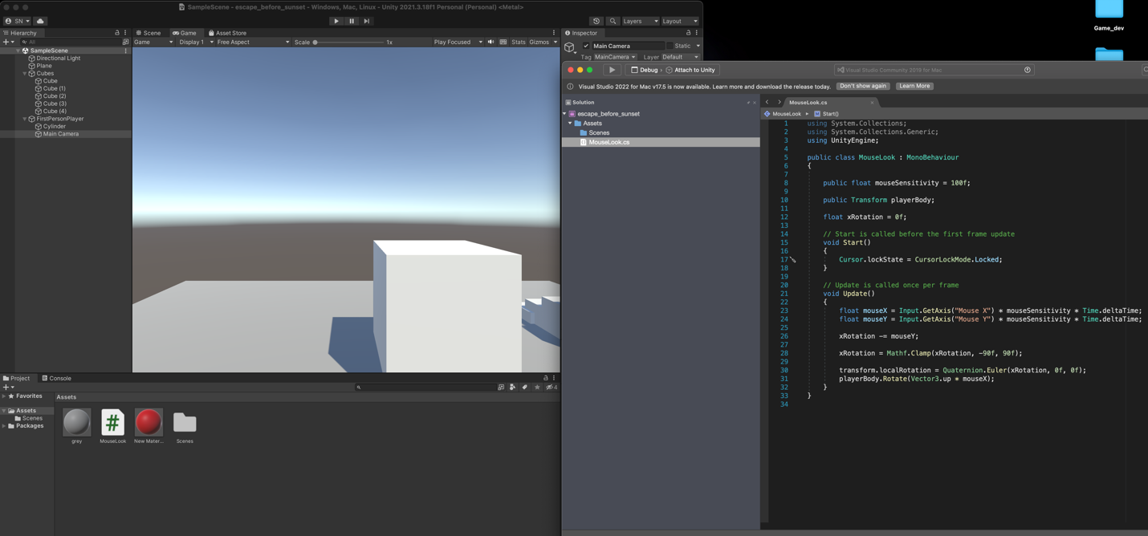

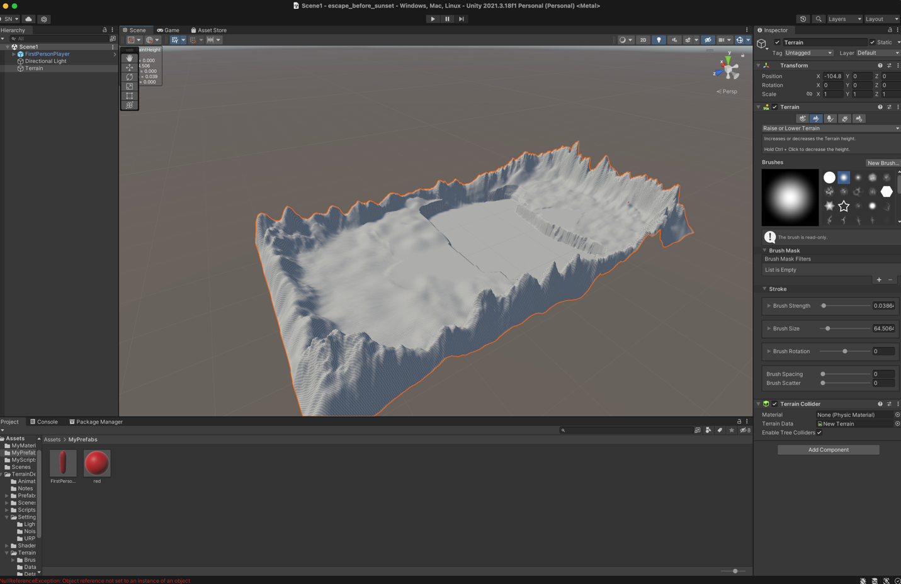

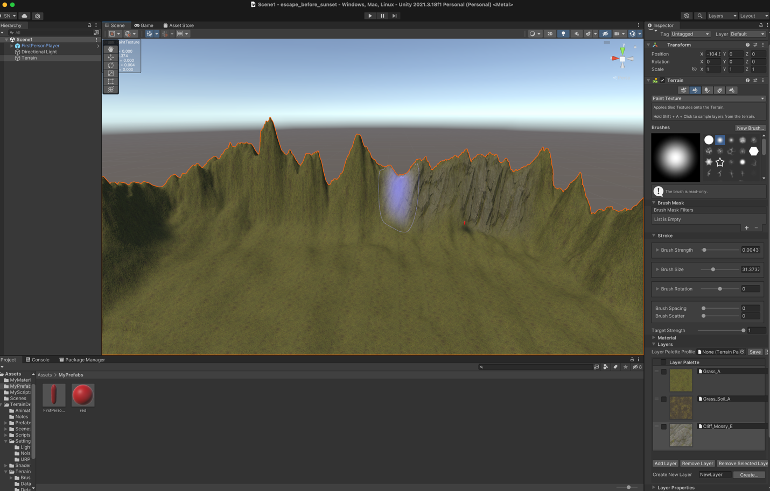

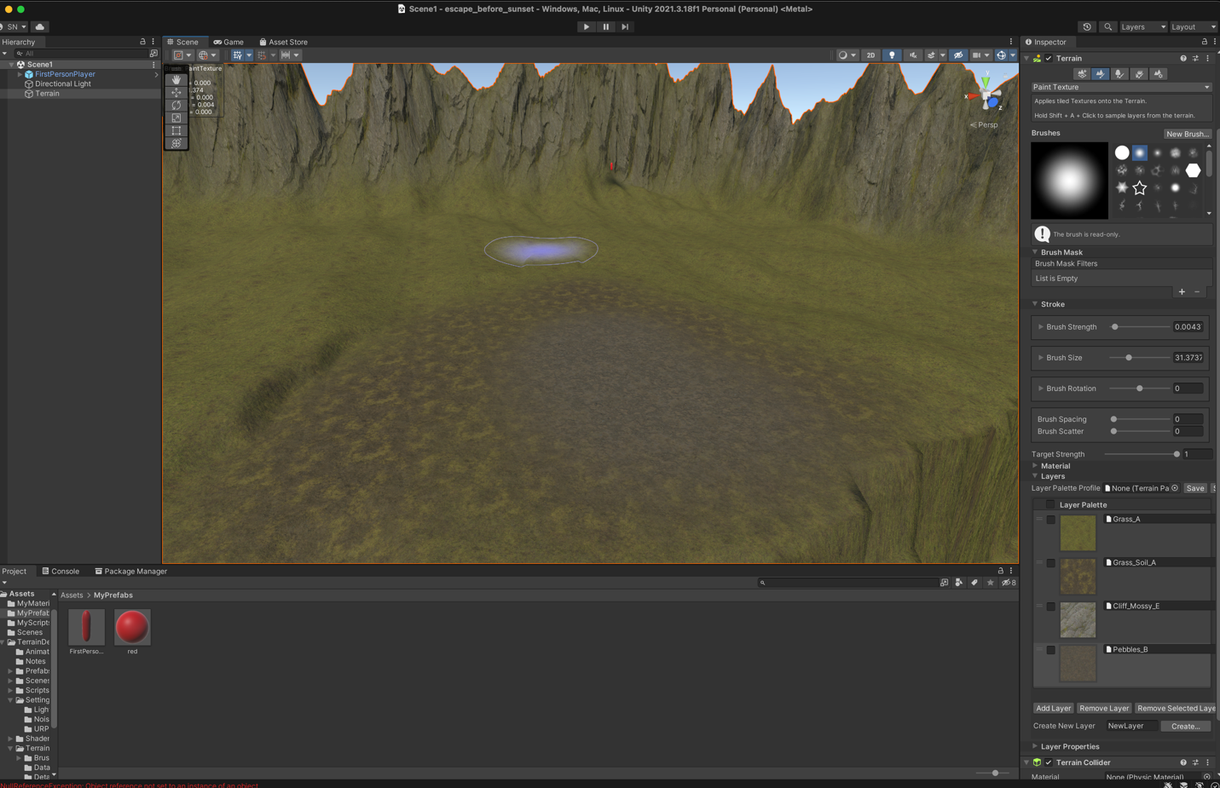

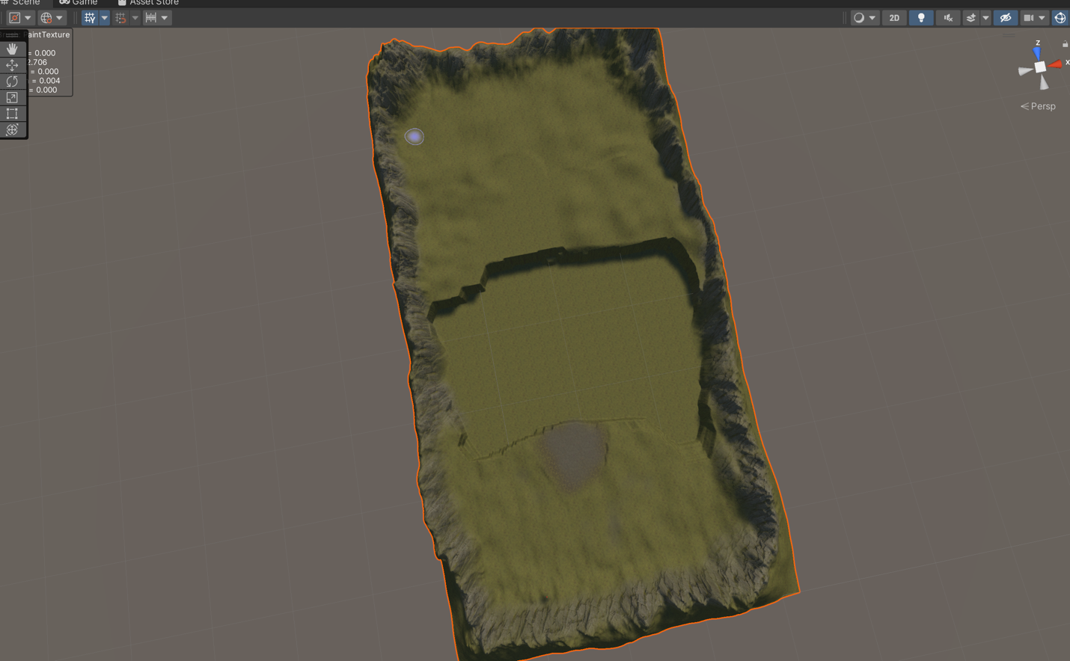

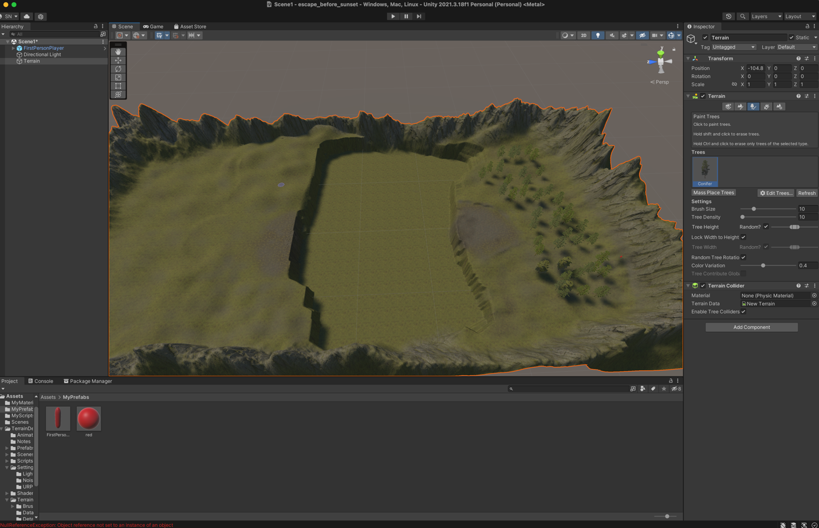

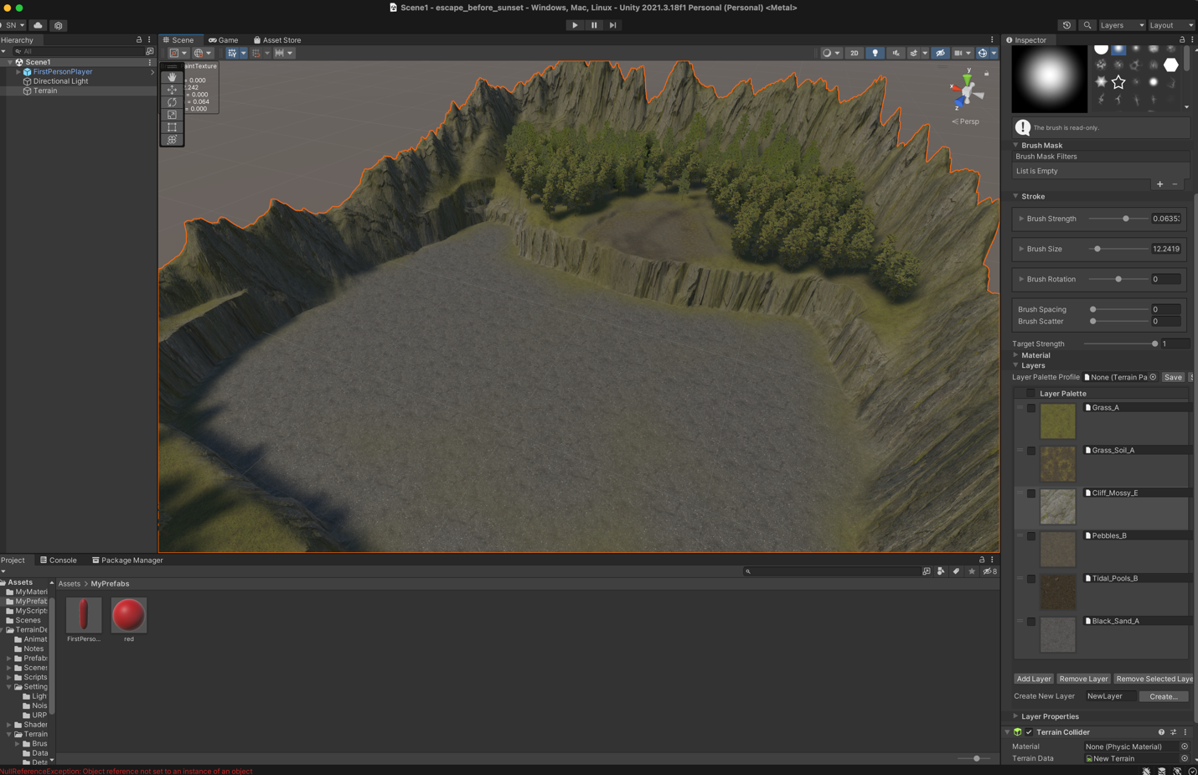

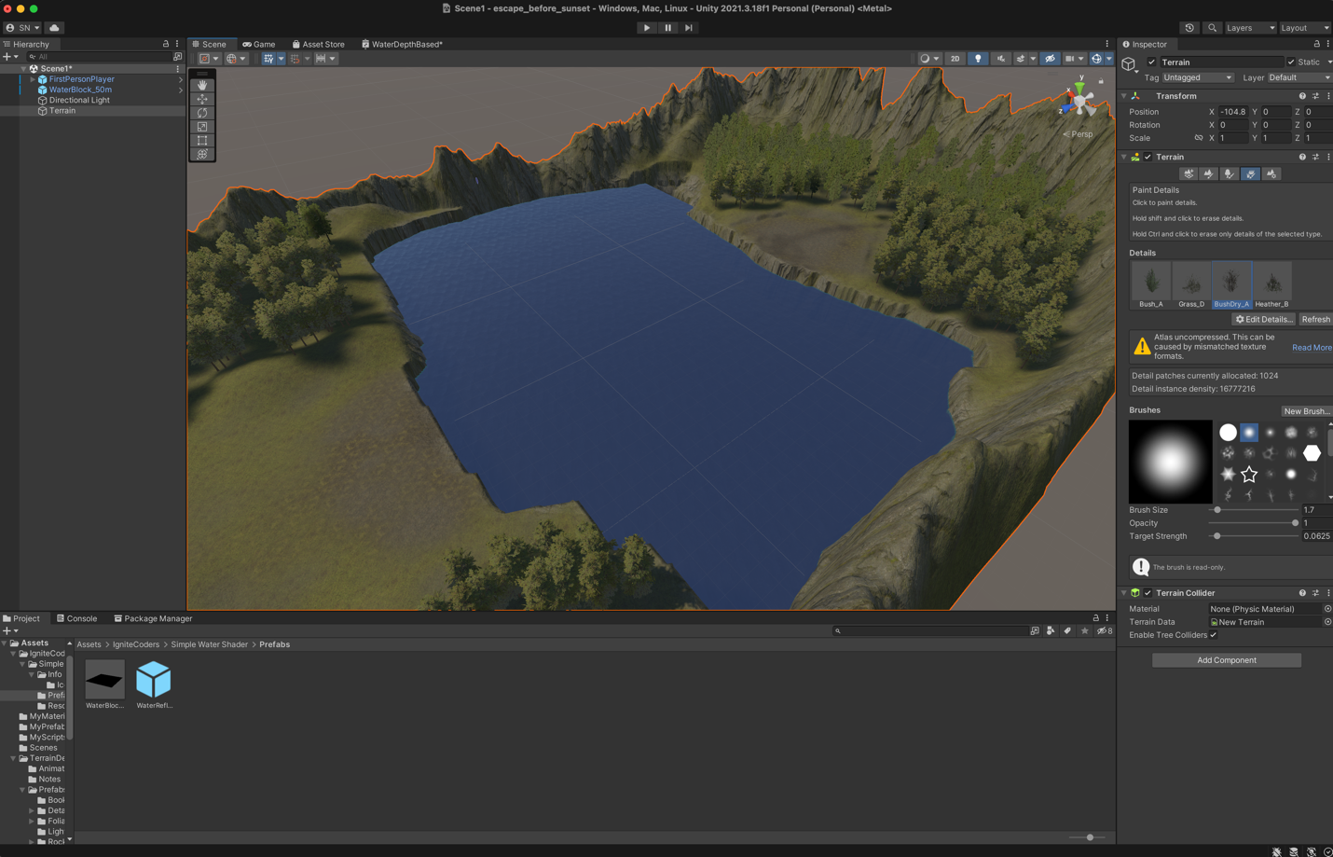

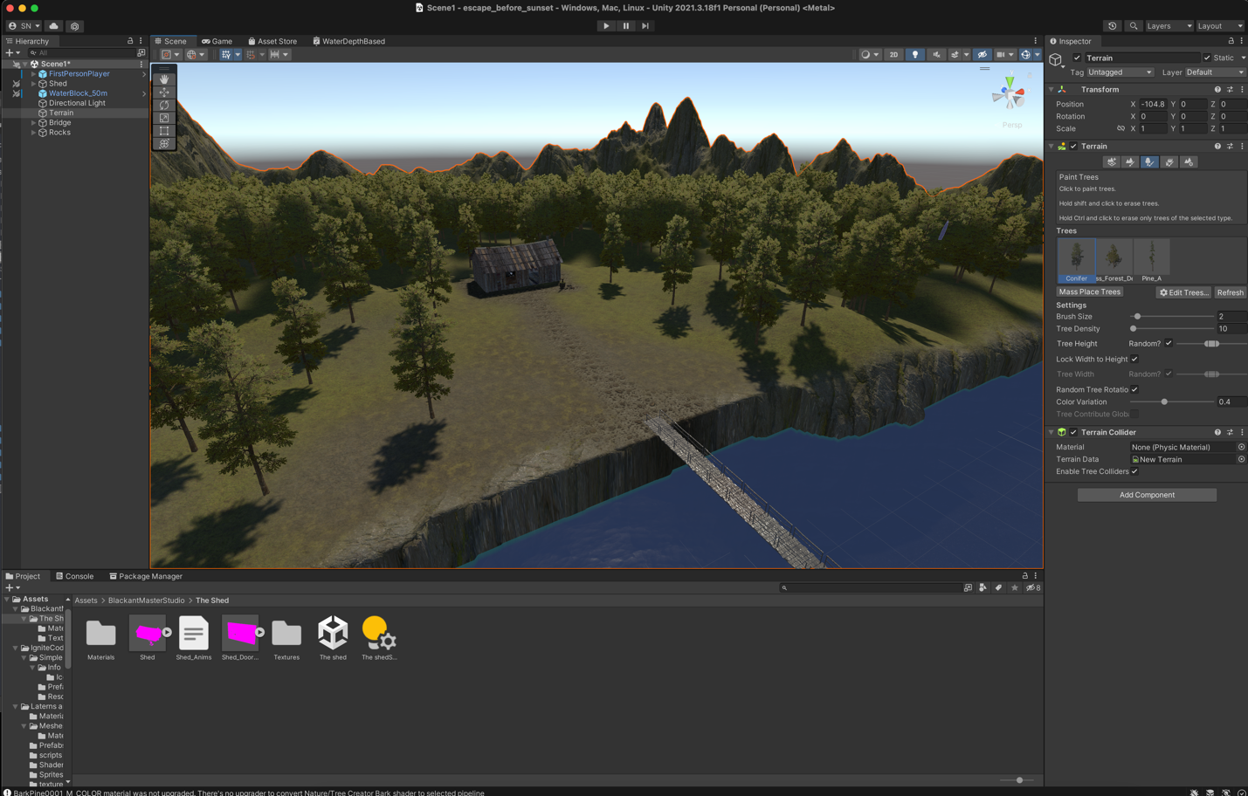

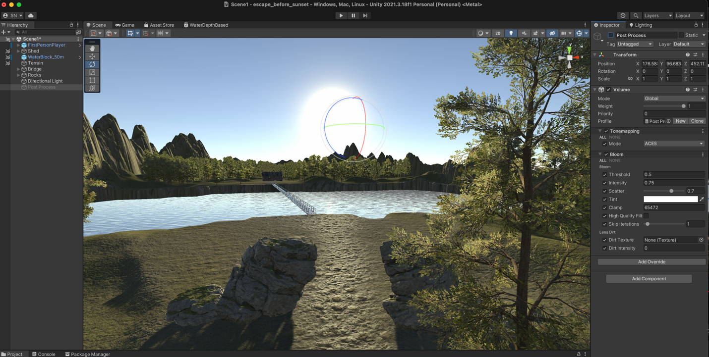

Without post processing (above)

With post processing (below)

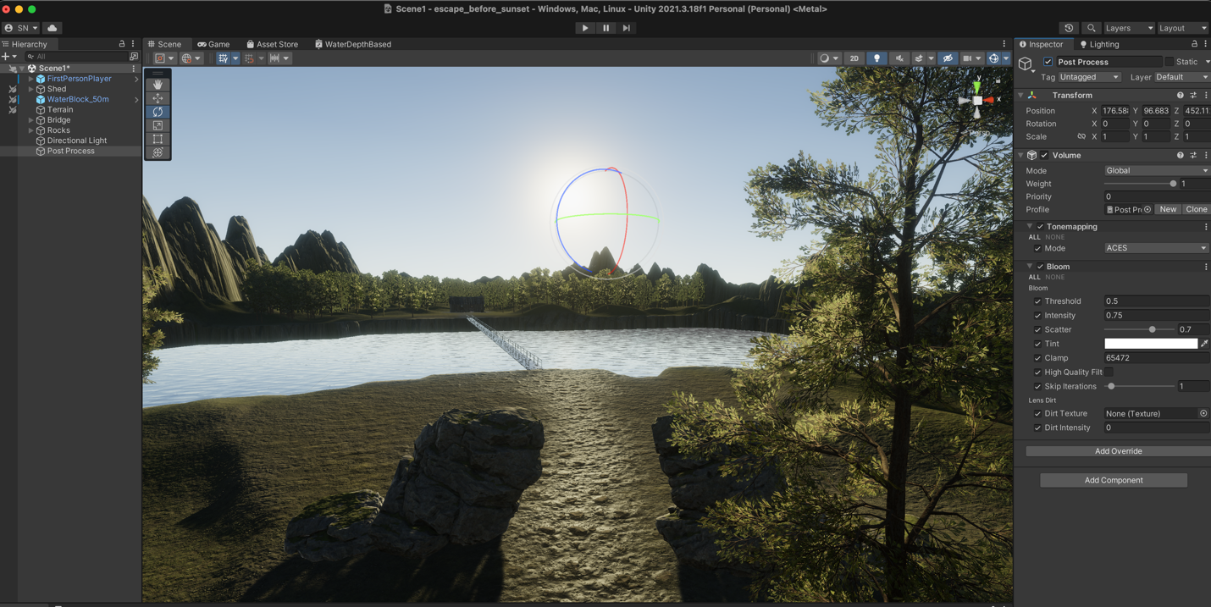

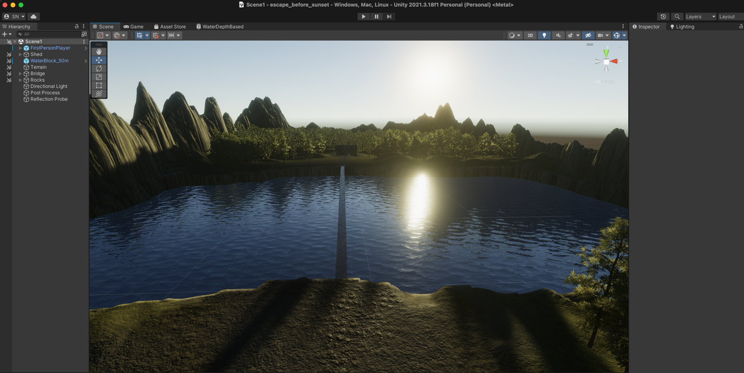

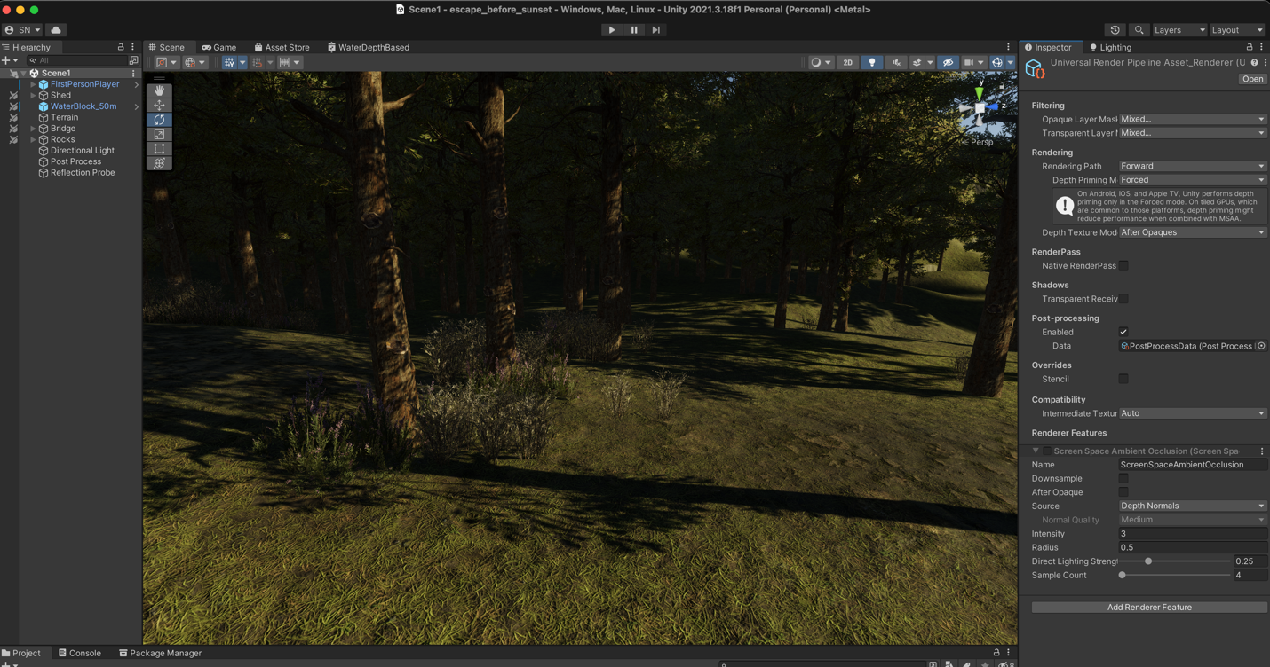

Without ambient occlusion (above)

With ambient occlusion (below)

